PERSONAL INFORMATION | Emmanouil Stamatakis
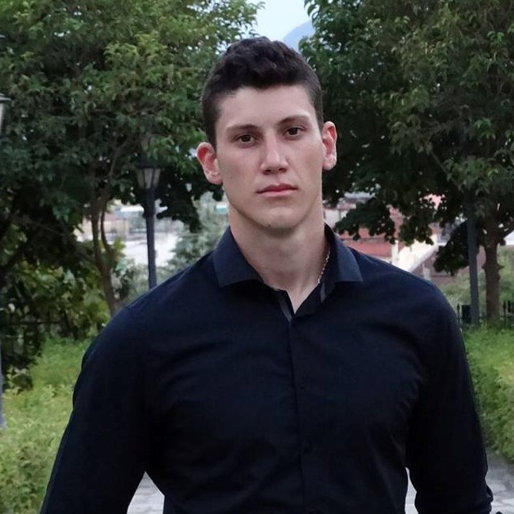 |   78 Sperchiou Road, Peristeri 12137, Athens, Greece
 |  0030 6976667762

EmmanouelStamatakes@gmail.com.com
 | Sex Male | Date of birth 05/02/1997 | Nationality Greek

profession | Programmer / Student

WORK EXPERIENCE

September 2015 – May 2017 | Volunteer Tutor
September 2015 – May 2017 | - Tutoring young children on the subjects of Physics and Mathematics.  - I have built two web sites in Html about Tourism.

EDUCATION AND TRAINING

September 2015 – June 2016 | Knowledge of programming languages  - Python  - C#  - Java  - JavaScript  - C/C++  - HTML-PHP  And several projects in the following languages  - In C# (Visual Studio)  - A program with one elevator and two elevators with one control panel in 6 floors building.  - A Photo Viewer with photo editing (stretch, zoom, cut, change style etc.)  - A Music Player connected with a Database for finding the top song or changing the name, type of music etc.  - A wonderful memory game with selected photos by the user which were shuffled and excepting from them to find them clicking on covered frame. Also, connected with Database for the Scoreboard.  - In Python (Atom)  - A Program which takes a numerical act with unnecessary parentheses, or not, and returns if this is right of wrong.  - A Program which removes unnecessary dots from a txt file returns and the correct one.  - Few programs connected with the APIs of Twitter and compares profiles.  - Java (Eclipse)  - An extensive program for clients (patients), doctors and administrators. This program works with a server and its purpose is to organize everyone's appointments  - JavaScript (Atom, p5.js)  - Amateur games like Snake and Flappy bird.
- Html-PHP (Notepad++)
- A professional web tour guide site about the world famous picturesque site of Meteora in Thessaly, with PHP booking system.
Strong Knowledge of Algorithms and Math’s.
Good Knowledge of MySQL Database.

Undergraduate student in the University of Piraeus in Greece.
• FOSCOM congress in the University of Piraeus 03/11/2015
• Oracle Academy Day by Oracle Hellas 11/29/2016
• 7th Connected World congress 05/04/2017

September 2013 – September 2015 | - In-depth knowledge of Astronomy, Physics, Mathematics  - General knowledge of Chemistry, Economics

PERSONAL SKILLS

Mother tongue(s) | Greek
Other language(s) | UNDERSTANDING |  | SPEAKING |  | WRITING
Other language(s) | Listening | Reading | Spoken interaction | Spoken production
English | Β1 | Β1 | B1 | B1 | B1
 | I’m going to have the Certificate of Proficiency in English (CPE) – University of Michigan in about a year
Levels: A1/2: Basic user - B1/2: Independent user - C1/2 Proficient user
Common European Framework of Reference for Languages

Mathematical skills | - Good computing skills gained through participating in and winning several Math contests.  - Good at optimization problems through participating in Math contests.

Organisational / managerial skills | - Committed to the task  - Hard-working  - Extremely organisational  - Increased analytical abilities  - Problem solving skills

Job-related skills | - Good at researching data bases, skill developed while undertaking various courses at the University  - Very good at working on computers, over 8 hours/day, skill developed while undertaking various courses at the University  - Capable of high quality, independent and team work both  - Great at meeting deadlines  - Multitasking

Computer skills | - Very Good use of programming environment such as: Visual Studio Enterprise 2017, p5.js, Atom, Eclipse  - Knowledge of Windows 10, Microsoft Office (awarded with the title of Microsoft Office Specialist) gained through computer studying since I was 12 years old.  - I have been awarded with the title of Microsoft Specialist by Microsoft.  That is my certifications in Date: Title  .  - 06/23/2010: Microsoft Office Word 2003  - 02/20/2012: Microsoft Office PowerPoint 2007  - 03/14/2012: Microsoft Office Access 2007  - 07/04/2012: Microsoft Office Outlook 2007  - 02/20/2013: Microsoft Office Excel 2007  - 04/24/2013: Microsoft Office Word 2007  - 03/26/2014: Adobe Photoshop CS6

Other skills | - Passionate reader  - Amateur photographer  - Excellent Discus Thrower, skill gained through years of training and participating in Sport Events  - Very good Sailor (Skipper), skill gained through 4 years of training on small boats (under 7 meters)  - Discipline and excessive willingness to succeed in my goals!

ADDITIONAL INFORMATION

Athletic Awards | - 22nd place at sailing, in the International Youth Championship 2012, Finland.  - 5th place at Discus throw in the Youth Panhellenic Championship 2014, Greece.  - 5th place at Discus throw in the Youth Panhellenic Championship 2015, Greece  - 3rd place at Discus throw in the Youth Panhellenic Championship 2016, Greece
Other Certifications | - 3rd place at Mathematical Olympics “Archimedes” 2015, Greece
- 3rd place at Panhellenic Microsoft Excel contest, 2011, Greece
- 2nd place at Panhellenic Microsoft Excel contest, 2012, Greece

